km
1 kilometer = ? meter
10
9
8
7
6
5
4
3
2
1

km
1 kilometer = 1000 meter

hm
1 hectometer = ? meter

hm
1 hectometer = 100 meter

dam
1 decameter = ? meter

dam
1 decameter = 10 meter

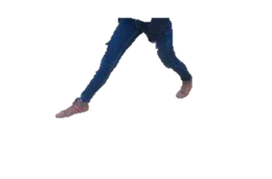

m
? meter

m
1 meter

dm
10 decimeter = ? meter

dm
10 decimeter = 1 meter

cm
100 centimeter = ? meter

cm
100 centimeter = 1 meter

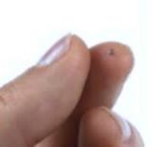

mm
1000 millimeter = ? meter
mm
1000 millimeter = 1 meter

